|  |  |  |  |  |
| --- | --- | --- | --- | --- |
|  | |  | | --- | | New Era University | | College of Informatics and Computing Studies  Department of Computer Science | |  |

**FREE ELECTIVE 3**CCSEL3-18

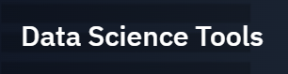

****by: **Cognitive Class**

ONLINE COURSE DOCUMENTATION

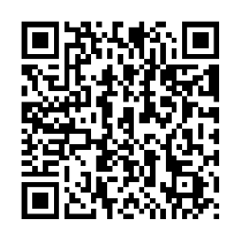

Marasigan, Vem Aiensi A.  
BS Computer Science | 21-11295-310

|  |  |
| --- | --- |
| **Module 1:** Language of Data Science | [ Completed by October 6 ] |

Basically, this module introduces languages used in Data Science. These are Python, R, and SQL. Not much is new here except for R since it wasn’t tackled before. Apart from that is the difference between Free and Open Source software, which is vaguely discussed in my opinion. Lastly mentioned are the other Languages, although not as popular as the aforementioned, but still exists in the ecosystem of Data Science.

|  |  |
| --- | --- |
| **Module 2:** Data Science Tools | [ Completed by October 22 ] |

This covered quite a lot of tools for data science. Due to the nature of data science, involving many processes, from tranformation to visualization, etc. there are many tools that already exists to aid data scientist. These can be group in categories which are:

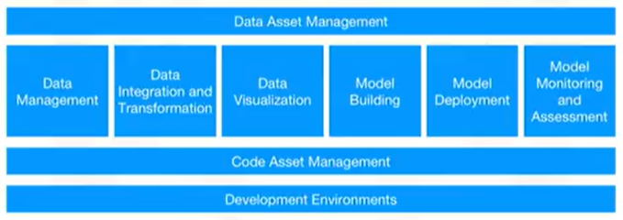

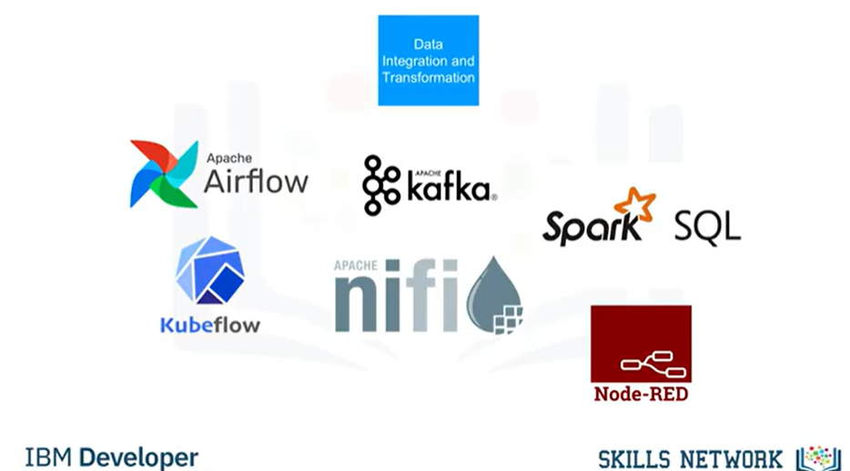There are quite a lot of tools and among those tools mentioned, the ones I personally have interests or had experience are PostgreSQL, Jupiter Notebooks, and Tensorflow for Machine Learning. Other open source tools not mentioned though are Tableu Public or even the simplest tools such as Google Spreadsheet.

*Just some examples from the module*

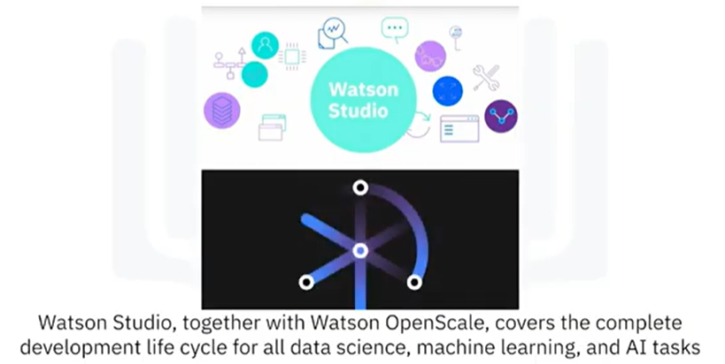Aside from open source tools, there are commercial ones too offering features that can cater all data science workflows. Some Highlighted here is:   
  
This commercial tool is also a cloud based platform.

|  |  |
| --- | --- |
| **Module 3:** Packages, APIs, Data Sets and Models | [ Completed by October 22 ] |

This module covered libraries used in data science along with the tools necessary to use those libraries. Another thing is the REST APIs which can be used to access pretrained or existing models, offering convinience to data scientist. Another thing to consider here are the licenses involved in using in using open source data sets and models. Here is some

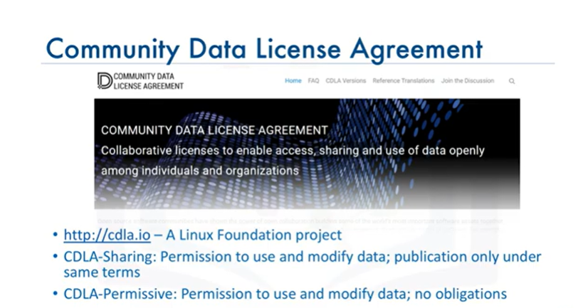

This module also offered a simple laboratory activity to try out data sets and jupyter notebooks

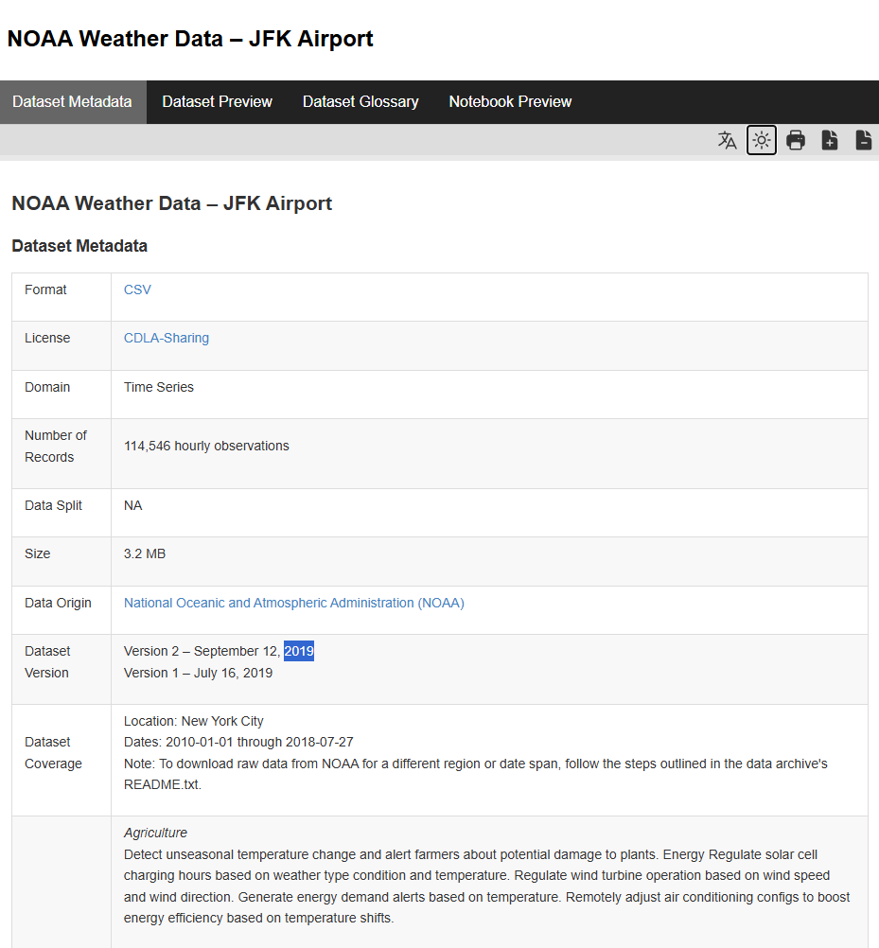 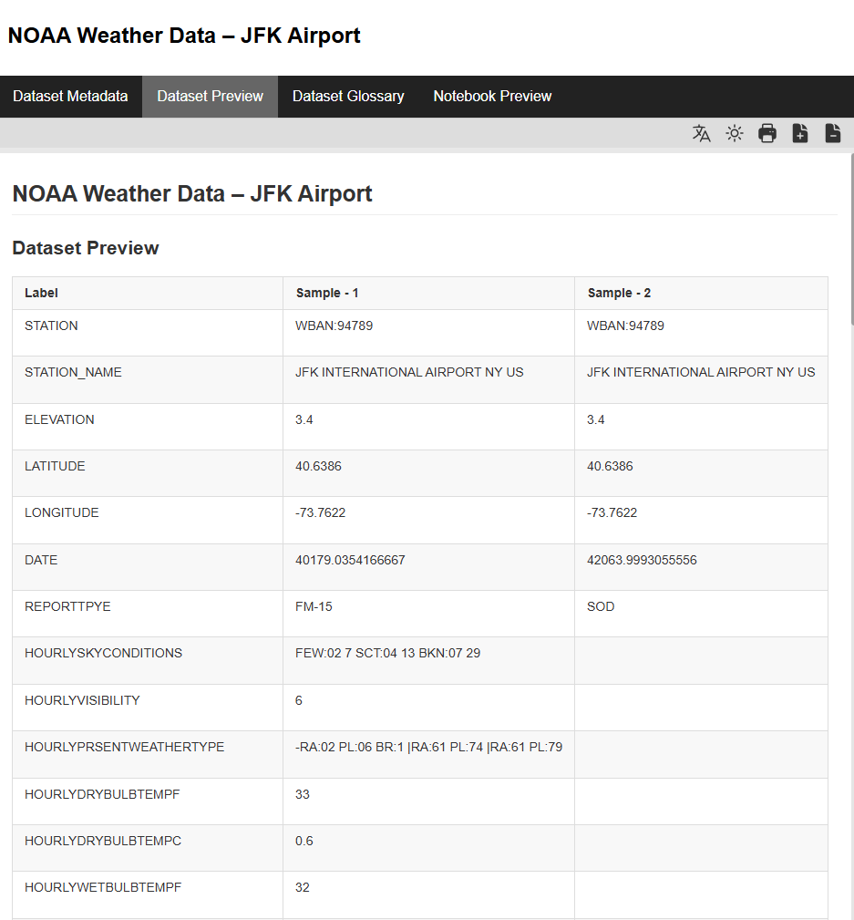

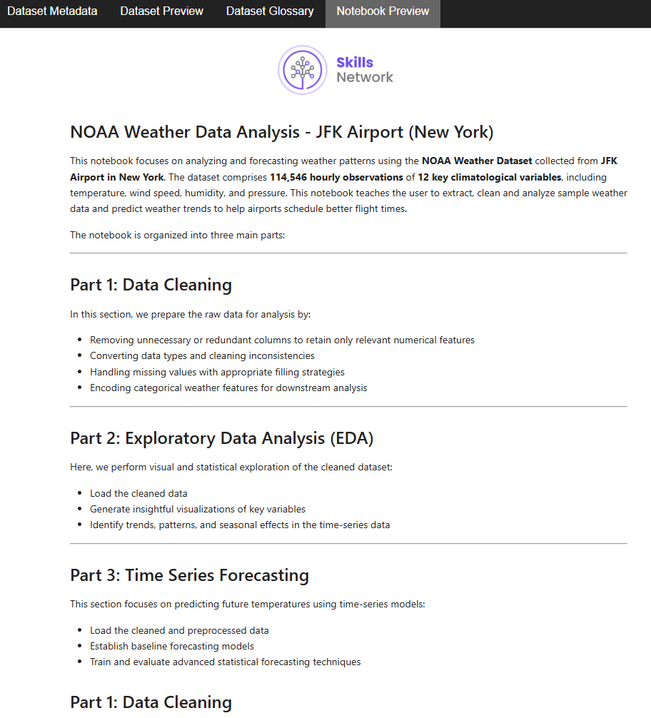

|  |  |
| --- | --- |
| **Module 4 & 5:** Git & Jupyter Notebooks | [ Completed by October 22 ] |

This module is pretty straightforward. Fundamentals of Git and Jupyter. It also covered GitLab and JupyterLab as well as practice labs.

|  |  |
| --- | --- |
| **Module 6:** R Studio | [ Completed by October 22 ] |

The module offered a lab for R Studio so since this would be my first time, I checked it out. This is laboratory 1 for R Studio:

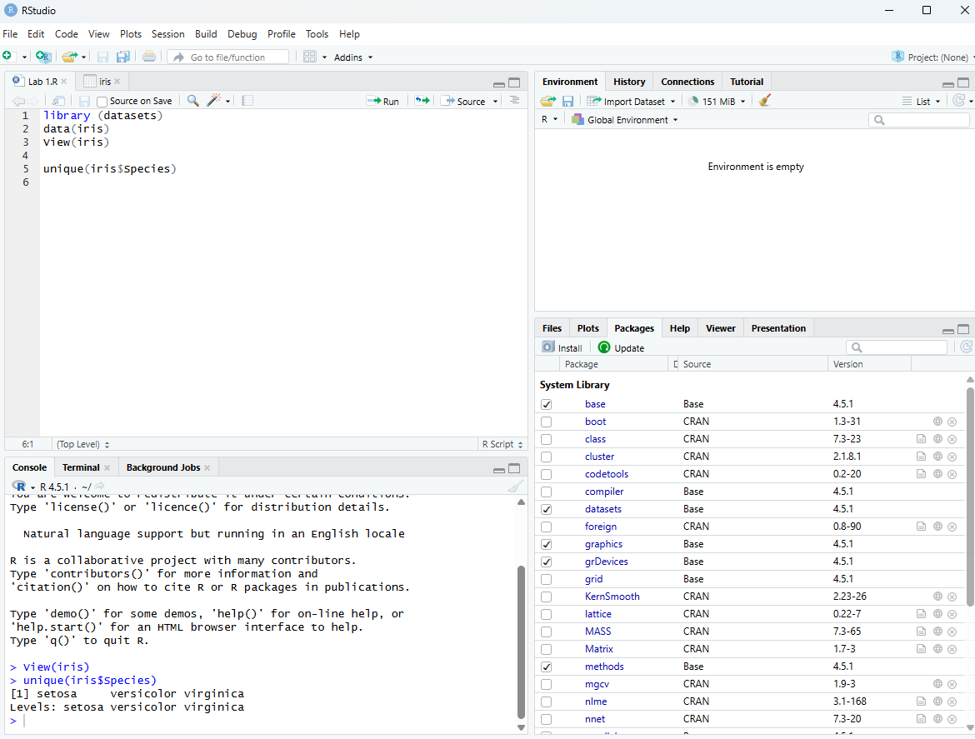

The second lab however doesn’t quite work as the module expects it to. I followed the instructions, copied the code exactly as it is but it’s kinda off. So, maybe I’ll come back to this later. Here is what I get though:

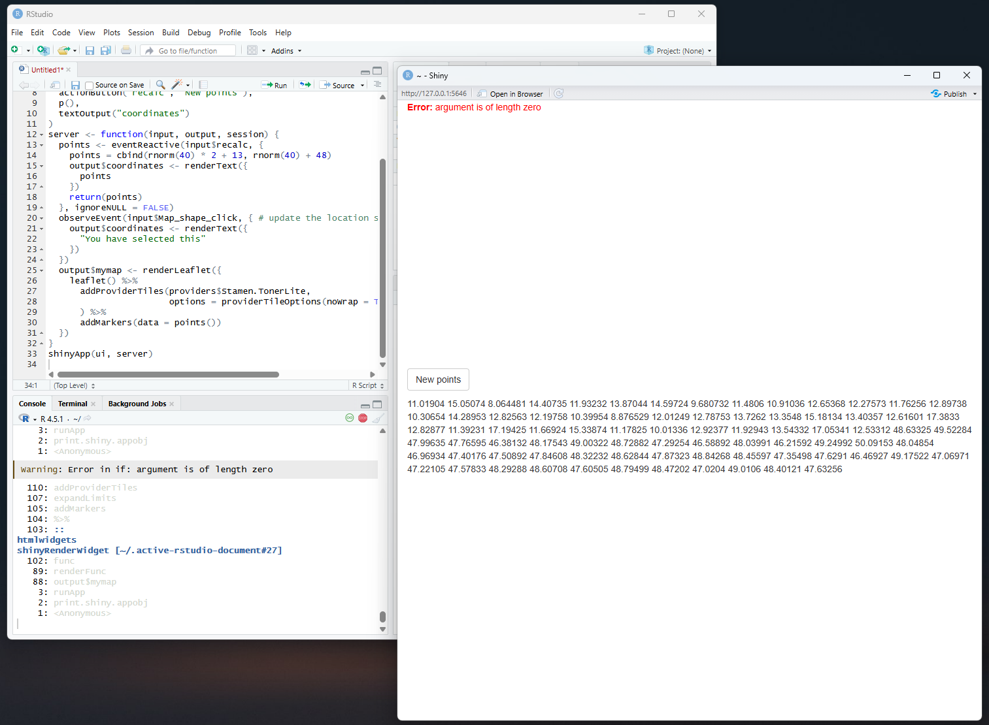

The proceeding instructions are also kinda hard to understand and can’t tell if I’m doing it right considering I haven’t got the expected outcome in the first place. Maybe it’s best to try other tutorials for R besides this one. Still, it’s a pretty descent module. It’s a beginner course anyway.

|  |  |
| --- | --- |
| **Module 6:** Watson Studio | [ Completed by October 24 ] |

*Unfortunately, as much as I love to, I cannot do any of the lab activities as my IBM Free Tier Account has already expired as I’ve already used it when learning DB2. Although we did managed to pass the Quiz!*

**COMPLETION RECORD**

